User interface design

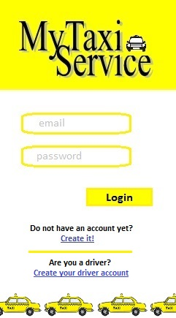

Image 6.1: Homepage/Login

When the user (driver and passenger) open his/her mobile application or the website, he/she sees this page. Then if he/she already has an account he/she fills in the form and click on the button “Login” (then he/she will be send to the page showed in Image 6.3 if he/she is a passenger and to the one showed in Image 6.8 if he/she is a driver). Otherwise the user can create a new account clicking on the link “Create it!” (Image 6.2) if he/she is a passenger or “Create your driver account” (Image 6.7) if he/he is a driver.

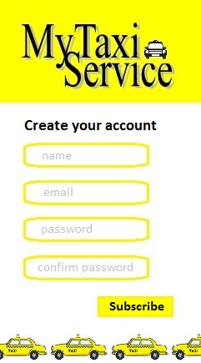

Image 6.2: Passenger creation account

The passenger fills in the form with all the information requested and clicking on the button “Subscribe” the system will check if email is valid and the two password inserted are the same. Then the passenger will see a page with the new profile created (Image 6.3).

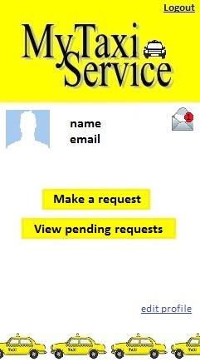

Image 6.3: Passenger profile

Through his/her own profile, the passenger can see his/her name, email and notification through the envelope on the right top of the page, make a request clicking on the related button (then the passenger will see the page showed in Images 6.5), see his/her incoming requests accepted or waiting to be accepted by a driver clicking on the related button (then the passenger will see the page showed in Image 6.6), edit the profile clicking on the related link, make the logout from the system.

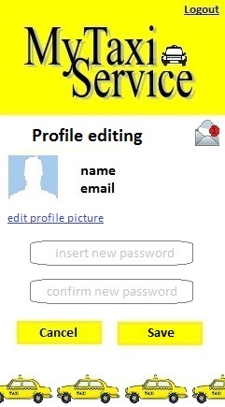

Image 6.4: Passenger profile editing

The passenger can only change his/her profile picture and change the password with a new one. The clicking on the button “Cancel” the system will return the passenger on the profile page (Image 6.3) without producing any changes otherwise clicking on the button “Save” the system will save all changes and will return on the profile page (Image 6.3). From this page the passenger can see the notifications and can logout from the system.

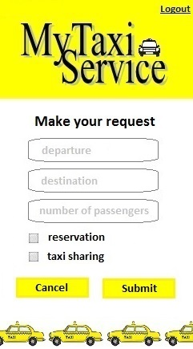 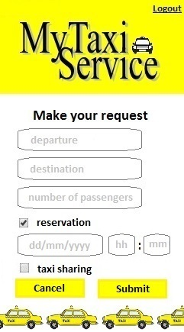

Images 6.5: Passenger request form

Through this form the passenger can make a request filling departure, destination and specifying if he/she want to make a simple request or a reservation (in this case is possible to choose day and time) and if he/she want to allow taxi sharing. Clicking on the button “Cancel” the system will show again to the passenger his/her profile page (Image 6.3) and clicking on “Submit” the system will add the request to the passenger’s pending requests (Image 6.6) and show the passenger his/her profile page (Image 6.3).

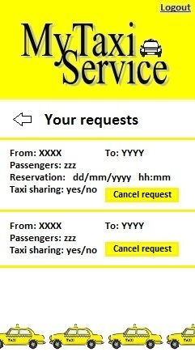

Image 6.6: Passenger’s pending requests

In this page the passenger can see all the requests he/she has done and which are waiting to be evaluated or have already been accepted/ignored by the driver. Clicking on the button “Cancel request” the passenger can cancel the request. Clicking on the arrow the system will show the passenger his/her profile page (Image 6.3).

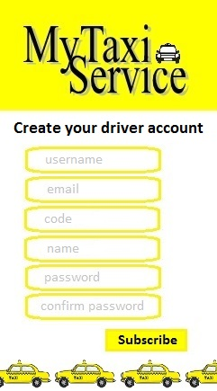

Image 6.7: Driver creation account

The driver fills in the form with all the information requested and clicking on the button “Subscribe” the system will check if username, email and code correspond to data stored in Milano’s database and the two password inserted are the same. Then the driver will see his/her new profile (Image 6.8).

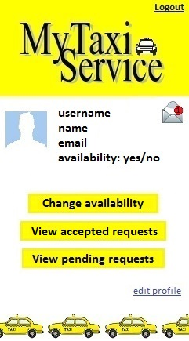

Image 6.8: Driver profile

Through his/her own profile, the driver can see his/her username, name, email, availability and notification through the envelope on the right top of the page, change availability clicking on the related button (then the driver will see the page showed in Image 6.9), see accepted requests clicking on the related button (then the driver will see the page showed in Image 6.10), see pending requests waiting to be accepted by him/her clicking on the related button (then the passenger will see the page showed in Image 6.11), edit the profile clicking on the related link, make the logout from the system.

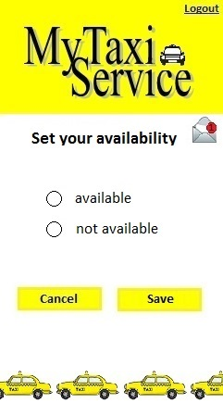

Image 6.9: Driver changing availability

Through this page the driver can change his/her availability selecting the option he/she wants to choose. Clicking on the button “Save” the system will save the changes otherwise clicking on “Cancel” the system will cancel changes. In both cases the system will return the driver to the profile page (Image 6.8).

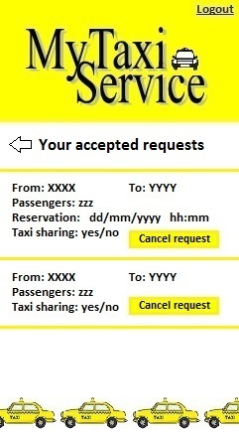

Image 6.10: Driver accepted requests

In this page the driver can see all the requests he/she has already accepted. He/she can cancel each of them by clicking on the button “Cancel request”. After deleting the request the passenger will see the same page (Image 6.10). Otherwise clicking on the arrow the system will show the driver his/her profile page (Image 6.8).

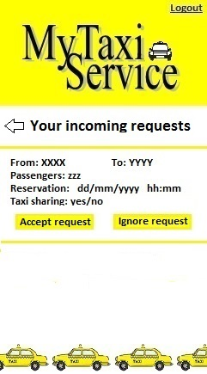

Image 6.11: Driver pending requests

In this page the driver can see all his/her incoming requests. For each request the driver can choose to accept or ignore it by clicking on the related button. Clicking on one of any of the previous buttons the system will return the driver on the same page (Image 6.11). Otherwise clicking on the arrow the system will show the driver his/her profile page (Image 6.8).

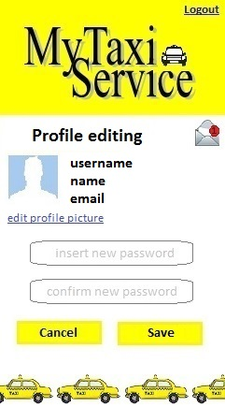

Image 6.12: Driver profile editing

The driver can only change his/her profile picture and change the password with a new one. The clicking on the button “Cancel” the system will return the driver on the profile page (Image 6.8) without producing any changes otherwise clicking on the button “Save” the system will save all changes and will return on the profile page (Image 6.8). From this page the driver can see the notifications and can logout from the system.